Creating the integration Object and updating the trust policy .

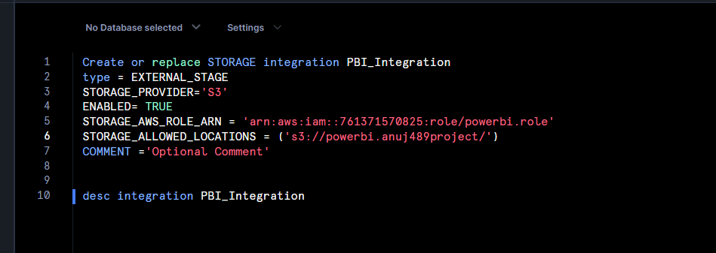

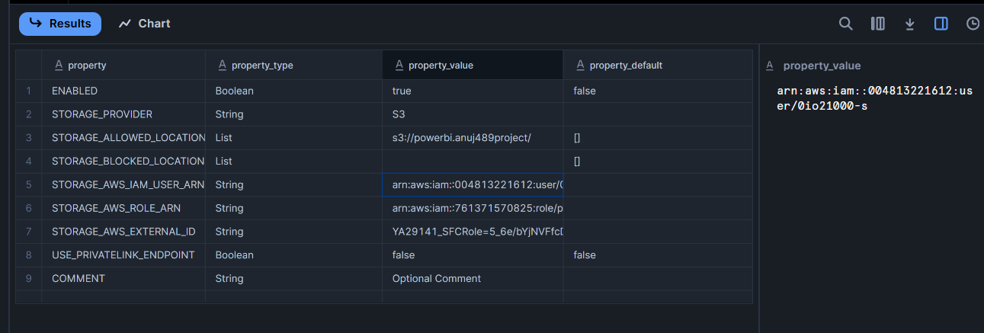

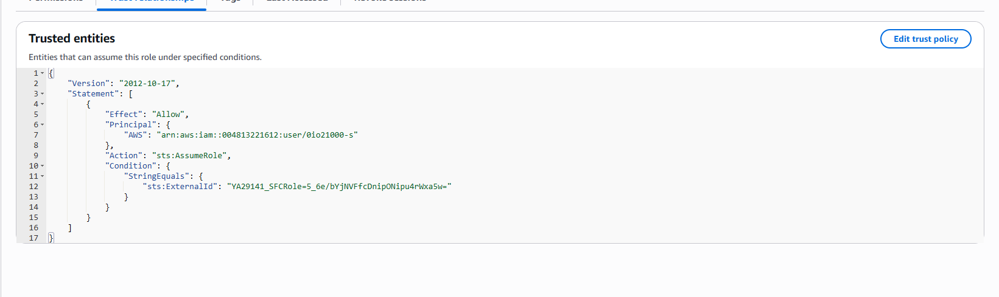

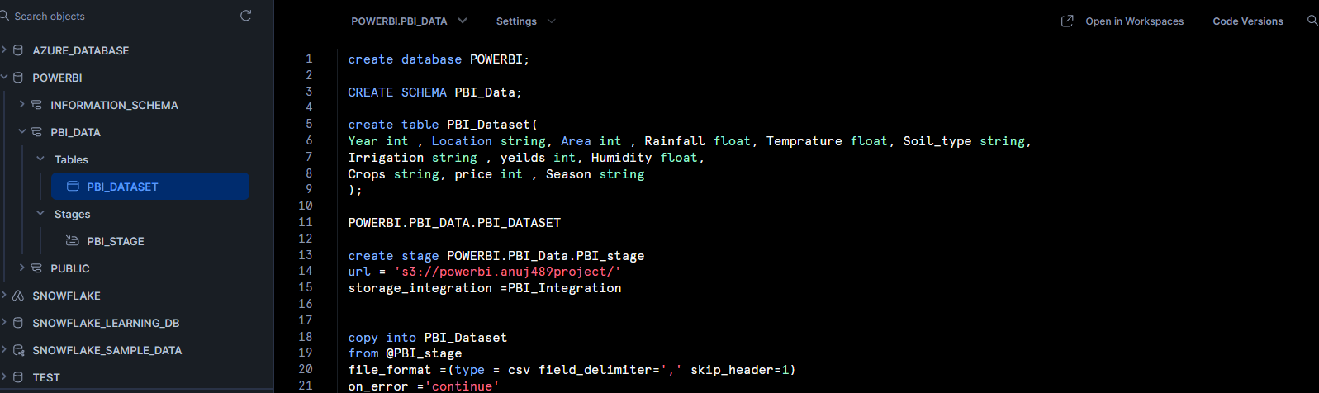

Successfully created the stage PBI_Stage and load the data into snowflakes.

### code ###

Create or replace STORAGE integration PBI_Integration

type = EXTERNAL_STAGE

STORAGE_PROVIDER='S3'

ENABLED= TRUE

STORAGE_AWS_ROLE_ARN = 'arn:aws:iam::761371570825:role/powerbi.role'

STORAGE_ALLOWED_LOCATIONS = ('s3://powerbi.anuj489project/')

COMMENT ='Optional Comment'

desc integration PBI_Integration

### sql query ###

create database POWERBI;

CREATE SCHEMA PBI_Data;

create table PBI_Dataset(

Year int , Location string, Area int , Rainfall float, Temprature float, Soil_type string,

Irrigation string , yeilds int, Humidity float,

Crops string, price int , Season string

);

select * from PBI_Dataset;

create stage POWERBI.PBI_Data.PBI_stage

url = 's3://powerbi.anuj489project/'

storage_integration =PBI_Integration

copy into PBI_Dataset

from @PBI_stage

file_format =(type = csv field_delimiter=',' skip_header=1)

on_error ='continue'

list @PBI_Stage

select year , count(*) from PBI_DATASET group by year;

create table agriculture as

select * from pbi_dataset;

select * from agriculture;

update agriculture set rainfall = 1.1*rainfall;

update agriculture set area=0.9*area;

select * from agriculture;

//2004 & 2009 - y1

// 2010 & 2015 - y2

// year 2016 & 2019 -y3

alter table agriculture

add year_group string;

// year group

update agriculture

set year_group ='Y1'

where year >=2004 and year <=2009

update agriculture

set year_group ='Y2'

where year >=2010 and year <=2015

update agriculture

set year_group ='Y3'

where year >=2016 and year <=2019

// raifall groups

// 255 to 1200 low

// 1200 to 2800 med

// 2800 to 4103 high

alter table agriculture

add Raifall_Groups string;

update agriculture

set Raifall_Groups ='low'

where rainfall >=255 and rainfall <1200

update agriculture

set Raifall_Groups ='medium'

where rainfall >=1200 and rainfall <2800

update agriculture

set Raifall_Groups ='high'

where rainfall >=2800

